JTETRIS LOGIC

# main loop of the game
-------------------------------------------------------------------------------

# Stage (official guide) is 10 cells wide. (lets make it 30 cells tall).
-----------------------------------------------------------------------------
stage = 2 dimentional array [ [0,0,0],
[0,0,0],
[0,0,0] ]
(x,y)
stage is rectangle (top_left_x,top_left_y) ,(bottom_right_x,bottom_right_y)

stage = min_x = 0, min_y =0, max_x = 10, max_y = 30

stage to screen coordinates => *cell_size

# blocks
-------------------------------------------------------------------------------
block has a pivot point (0,0) – in block space
- and rest of the cells relative to pivot – depending on the shape of the block

#blocks
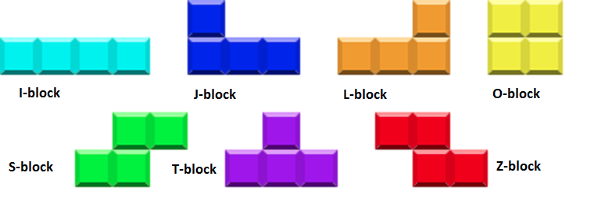

we have 7 different possible blocks

I – block
J – block
L – block
O – block
S – block
T – block
Z – block

(they all can be rotated in 90degrees steps).

cell is a basic bulding blocks for block

Blocks ‘appear’ at the top and falls one cell at the time – when time may vary. (slow at the begginign – fast at later stage).

